**Question 3**

Query 1:

with

consecutive_days AS (

SELECT

Cust_Id,

Calendar_Dt,

Amt_LE,

(ROW_NUMBER() OVER (PARTITION BY Cust_Id ORDER BY Calendar_Dt)) as seq,

DATE_ADD(Calendar_Dt, INTERVAL - (ROW_NUMBER() OVER (PARTITION BY Cust_Id ORDER BY Calendar_Dt)) DAY) AS grp

FROM transactions

),

max_consecutive_days AS (

SELECT

Cust_Id,

Calendar_Dt,

Amt_LE,

seq,

grp,

COUNT(grp) over(partition by Cust_Id,grp) AS consecutive_days_count

FROM consecutive_days

WHERE Amt_LE > 0

)

SELECT Cust_Id, max(consecutive_days_count)

FROM max_consecutive_days

group by Cust_Id;

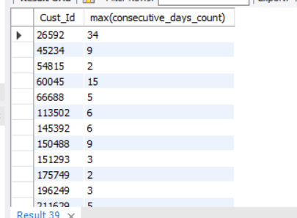

The CTE, **consecutive_days**, groups the purchases by customer and creates a new grouping column **grp** based on the difference between the row number and the calendar date. This grouping column is used to calculate the number of consecutive days each customer made purchases.

the **max_consecutive_days** CTE counts the number of distinct groups of consecutive days each customer made purchases, filters out zero purchase amounts, and groups by customer.

The outer query selects the maximum count of consecutive days made by each customer.

This is an output for all columns which I used to calculate this final result:

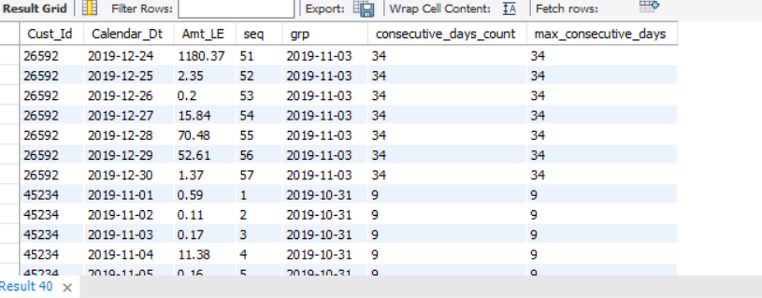

Query 2:

with cte as(

select cust_id,calendar_dt,amt_le,sum(amt_le) over(partition by Cust_Id order by Calendar_Dt) as total_amount

from transactions)

, cte2 as(

select *,case when total_amount >= 250 then 1 else 0 end as reached_threshold

from cte

where total_amount >= 250

),

cte22 as (SELECT cust_id, min(cte2.calendar_dt) final_date

FROM cte2

group by cust_id),

cte1 as(

select *,case when total_amount >= 250 then 1 else 0 end as reached_threshold

from cte

where total_amount <250

),cte11 as(SELECT cust_id, min(cte1.calendar_dt) first_date

FROM cte1

group by cust_id

),

final as (select c1.cust_id, datediff(final_date , first_date) as days_before_reaching_threshold

from cte11 c1 ,cte22 c2

where c1.cust_id = c2.cust_id)

select avg(days_before_reaching_threshold) as total_avg_days_before_reaching_threshold

from final

;

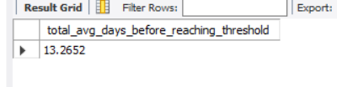

Before taking the average …here is every count of days each customer takes to reach the threshold

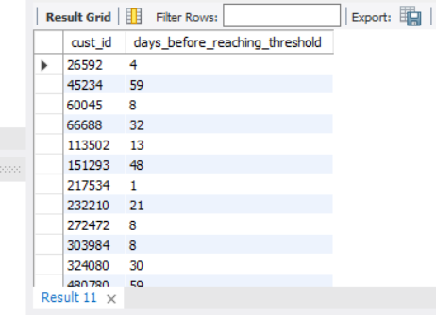

I decided to count the days not the count of transactions as customers may make a few transaction in a long time period

But if u want count of transactions of each customer not to count the days

I made this query here is every count of transactions each customer takes to reach the threshold

Another answer:

with cte as(

select cust_id,calendar_dt,amt_le,sum(amt_le) over(partition by Cust_Id order by Calendar_Dt) as total_amount

from transactions)

, cte2 as(

select *,case when total_amount >= 250 then 1 else 0 end as reached_threshold

from cte

where total_amount >= 250

),

cte1 as(

select *,case when total_amount >= 250 then 1 else 0 end as before_reached_threshold

from cte

where total_amount <250

),

final as (select c1.cust_id, count(before_reached_threshold) as Transaction_before_reaching_threshold

from cte1 c1

where c1.cust_id in (select cust_id from cte2)

group by c1.cust_id)

select *

from final

;

Here is the average:

